Phase 2  ------------------ Transactions

Allowance Statements

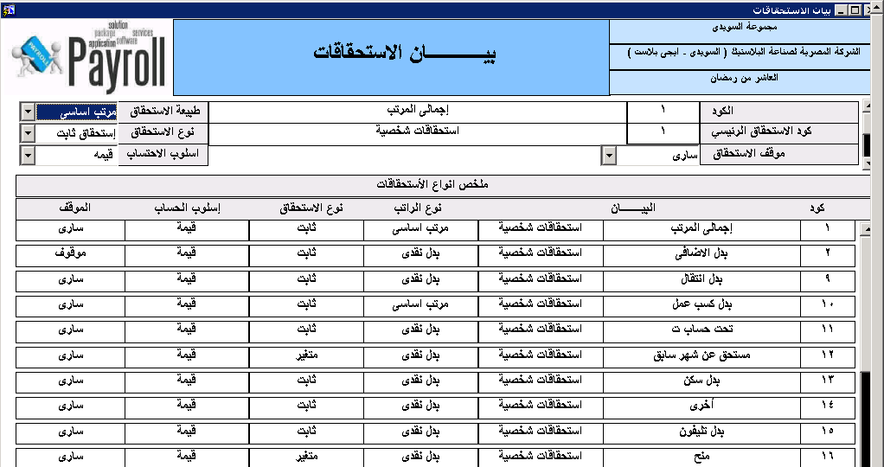

1 – Allowance Code ---------- Auto Serial

2- Nature --- Basic salary or Cash allowance

3- Allowance Category ----- Personal Allowance or Job Allowance

4- Allowance Type – Fixed Allowance or Variable Allowance

5- Calculation --- Value – Percentage – Days – Hours

6- Status – Active – Stopped

We will add

7- Insurance Status --- Included in the Fixed Insurance – included in Variable Insurance – Not Included

8- Tax Status – Included in Tax Calculation – Not Included

Deductions Statements

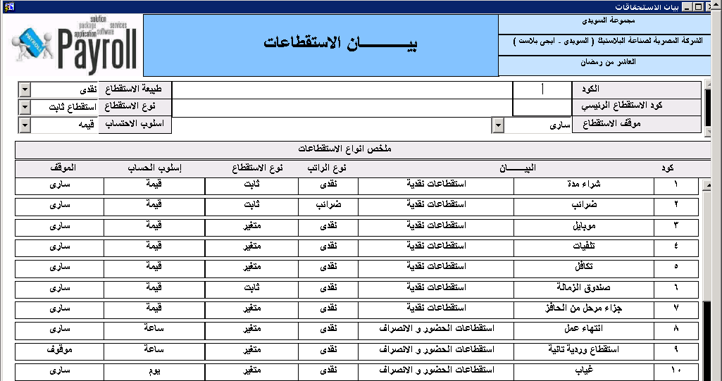

1– Deductions Code ---------- Auto Serial

2- Nature --- Cash Deductions - Other Deductions

3- Deductions Category ----- Job Deductions - Attendance Deductions

4- Deductions Type – Fixed Deductions or Variable Deductions

5- Calculation --- Value – Percentage – Days – Hours

6- Status – Active – Stopped

We will add

7- Insurance Status --- Excluded from the Fixed Insurance – Excluded from Variable Insurance – Not Excluded

8- Tax Status – Excluded from Tax Calculation – Not Excluded

Employee Fixed Allowance & Deductions

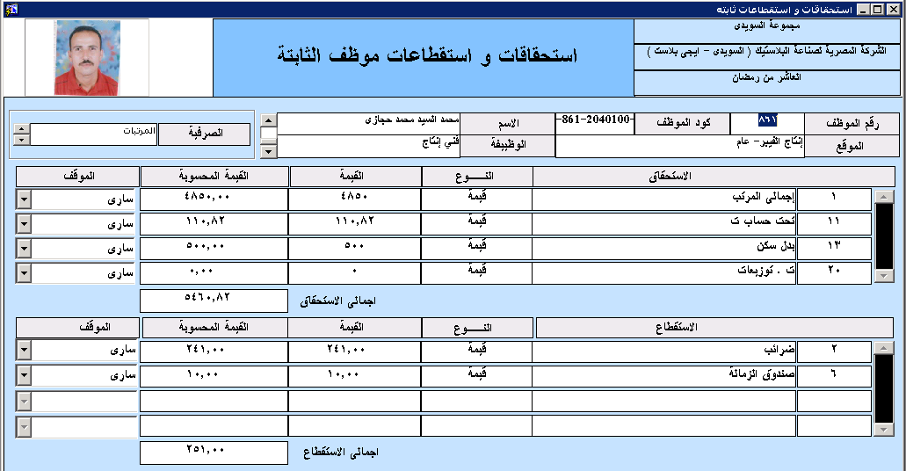

**First Block**

**View**

Emp Code

Emp name

Job & Location

**Second Block**

**Create Record**

Allowance Code + Description + Calculation + Value + Calculated Value + Status

Calculated value

1 – Value ( Calculated Value = Entered Value )

2- Percentage ( Select all allowance Nature = Basic salary * Per Value /100)

3- Days ( Select all allowance Nature = Basic salary/30 * days Value)

4- Hours ( Select all allowance Nature = Basic salary/210 * days Value)

Total Allowance Calculated Values

**Third Block**

**Create Record**

Deduction Code + Description + Calculation + Value + Calculated Value + Status

Calculated value

1 – Value ( Calculated Value = Entered Value )

2- Percentage ( Select all Deductions Nature = Cash Deductions * Per Value /100)

3- Days ( Select all Cash Deductions Nature = Cash Deductions /30 * days Value)

4- Hours ( Select all Cash Deductions Nature = Cash Deductions /210 * days Value)

Total Deductions Calculated Values

Employee Variable Allowance & Deductions

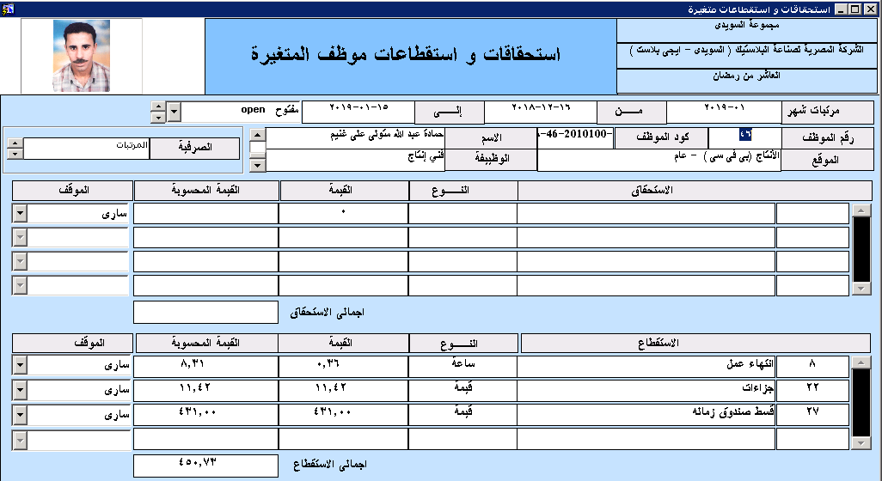

**First Block**

Open Period – Open Month For Transactions

Salary Month – Start From – End Date – Status ( Opend – Closed )

**Second Block**

**View**

Emp Code

Emp name

Job & Location

**Third Block**

**Create Record**

Allowance Code + Description + Calculation + Value + Calculated Value + Status

**Fourth Block**

**Create Record**

Deduction Code + Description + Calculation + Value + Calculated Value + Status

Loans

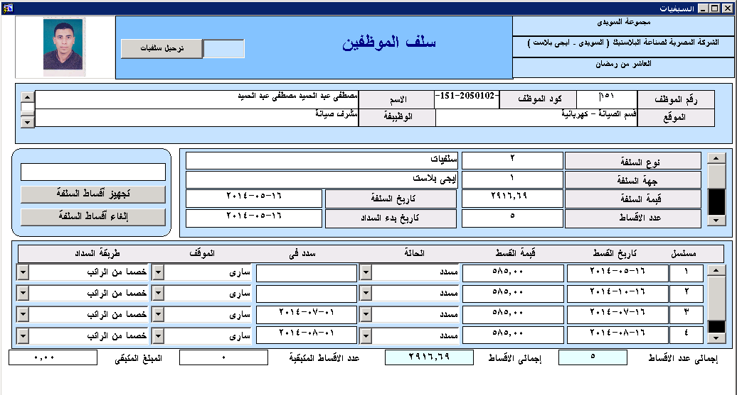

**First Block**

**View**

Emp Code

Emp name

Job & Location

**Second Block**

**Loan Type** -- Drop List

(Personal Loan – Training loan - Medical Loan – Damaged Loan – hadj ( ....

Spending Loan Location -- Company …..

Loan Value --- Value

Loan Installments

Loan Start Date

**Prepare Loan**

Create Records

Loan Value / Installments

Create Record for Every Installment Starting from Starting Date + 1 Month until end of Installments

Every Installment with fixed Value and the Remain on the Last Installment

Status – Paid – owing

Paid Month --- Updated after Salary Calculation for Every month

Installment Status – Active – Stopped

Deducted From – Salary – Direct Cash

Last Block

View

Installments Numbers

Loan Value

Owing Value

Owing Installments

Mobile Deductions

